Data Structure and Algorithm

Laboratory Activity No. 6

Singly Linked Lists

| *Submitted by:* | *Instructor:* |
| --- | --- |
| Elpedes, Glen Jorge A. | Engr. Maria Rizette H. Sayo |

August, 23, 2025

# Objectives

Introduction

A linked list is an organization of a list where each item in the list is in a separate node. Linked lists look like the links in a chain. Each link is attached to the next link by a reference that points to the next link in the chain. When working with a linked list, each link in the chain is called a Node. Each node consists of two pieces of information, an item, which is the data associated with the node, and a link to the next node in the linked list, often called next.

This laboratory activity aims to implement the principles and techniques in:

* Writing algorithms using Linked list
* Writing a python program that will perform the common operations in a singly linked list

# Methods

* Write a Python program to create a singly linked list of prime numbers less than 20. By iterating through the list, display all the prime numbers, the head, and the tail of the list. (using Google Colab)
* Save your source codes to GitHub

# Results

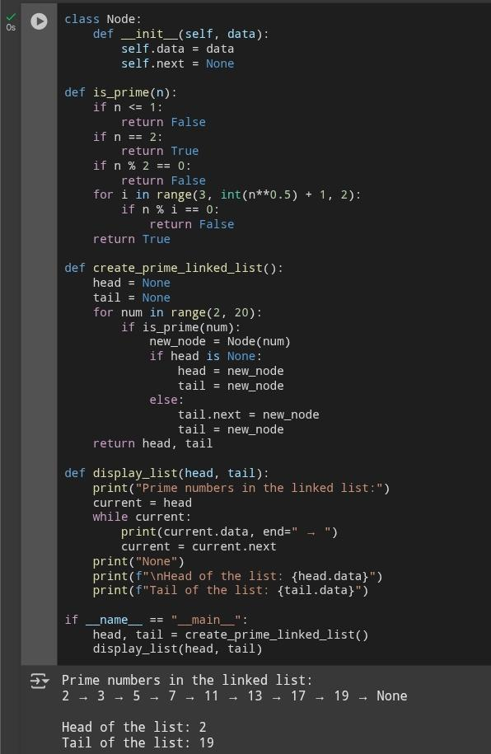

Figure 1

# Conclusion

This exercise walks you through the process of building a singly linked list in Python to hold prime numbers smaller than 20. It covers important steps such as defining a Node class, putting in place a prime-checking function, iterating through the numbers and connecting nodes to build the list, and displaying the list along with its head and tail. It integrates prime-number logic and strengthens knowledge of linked list structure (nodes with data and next pointers) and operations (traversal, head/tail identification).

**References**

[1] “Generate a list of Primes less than n in Python.” <https://sg-link.byteoversea.com/?aid=489823&lang=en&scene=im&jumper_version=1&target=https%3A%2F%2Fwww.tutorialspoint.com%2Fgenerate-a-list-of-primes-less-than-n-in-python%3Fneed_sec_link%3D1%26sec_link_scene%3Dim&theme=light>

[2] Deepak, “Random Singly Linked List Generator using Python,” CodeSpeedy, Sep. 15, 2021. <https://www.codespeedy.com/random-singly-linked-list-generator-using-python/?need_sec_link=1&sec_link_scene=im>